Roadkill Hotspots and Policy Advocacy (RHPA): A Multi-Layered AI and IoT Approach for Real-Time Wildlife Preservation
Lokesh Patra¹, Indigibilli Harshit¹, Saumendra Kumar Mohapatra², Apurva Singh³, Mihir Narayan Mohanty³
1Faculty of Engineering & Technology Sri Sri University, Cuttack, India lokesh0patra@gmail.com harshitindigibilli@gmail.com 2Faculty of Engineering & Technology Sri Sri University, Cuttack, India
saumendra.m@srisriuniversity.edu.in
3Department of ECE
Sri Sri University / Siksha ’O’ Anusandhan University, Odisha, India apoorva.apurva.2004singh@gmail.com mihirmohanty@soa.ac.in

Abstract—Roadkill episodes are a crucial point where vehicle safety risks and ecological damage converge. The frequency of wildlife-vehicle incidents has increased due to rising urbanization, posing a threat to commuters and causing a major loss of bio- diversity. In this study, a novel three-dimensional (3D) approach called "Roadkill Hotspots and Policy Advocacy" (RHPA) is proposed. In contrast to conventional radar-based systems, RHPA creates a preventive and responsive ecosystem by combining Computer Vision (YOLOv5xu), Deep Learning (DenseNet121 and EfficientNet-B3), and the Internet of Things (IoT). Both CNN architectures are trained individually to categorize subjects as “Alive” (High Risk) or “Dead” (Low Risk), achieving an overall accuracy of approximately ≈95%, and YOLOv5xu for real-time detection. Additionally, the system incorporates a policy-level dashboard to detect blackspots and an ESP32-based actuation layer for real-time driver warnings. Pilot testing indicates a potential 36% reduction in roadkill incidents.
Index Terms—Road Ecology, YOLOv5xu, DenseNet121, Effi- cientNet, IoT, Smart Cities, Wildlife Conservation.

- Introduction
The expansion of road networks acts as a double-edged sword; while it facilitates economic growth, it fragments natural habitats, forcing wildlife to navigate hazardous asphalt terrains. Personal observations over a three-year daily com- mute of 40 km revealed a grim reality: the daily presence of roadkill ranging from domestic vertebrates (dogs, cows) to wild species (mongooses, snakes). These incidents are not merely ecological statistics; they represent a traumatic experience for drivers and a sanitary crisis for municipal authorities.
Existing solutions often rely on passive signage or prim- itive radar systems that lack visual verification. This paper introduces a 3D AI-based solution:
- Dimension 1 (Vision): Real-time detection and tracking.
- Dimension 2 (Classification): Distinguish between live threats and carcasses to automate different responses.
- Dimension 3 (Actuation): IoT-based warnings and au- tomated municipal reporting.
The foundation of this research is based on the analysis of gaps in existing road ecology frameworks. Ahn and Bae proposed a “Sound Warning System for the Prevention of Roadkill” that uses radar to detect movement and emit ul- trasonic frequencies [1]. Although their approach successfully deters some animals, radar systems suffer from a high false- positive rate (triggering for inanimate objects) and cannot distinguish between a living animal crossing the road and an already deceased one. Our proposed RHPA system overcomes this by replacing the radar with Computer Vision (YOLOv5xu) for granular object classification.
The research by van der Ree et al. and van Langevelde highlights the theoretical relationship between traffic flow and mammalian mortality [2]. They suggest that infrastructure modification (underpasses) is the gold standard. However, such infrastructure is expensive and slow to implement. The RHPA project proposes a “Policy Advocacy” layer, using data- driven heatmaps to identify exactly where such infrastructure is needed, bridging the gap between theoretical ecology and smart city implementation.

- System Architecture

The proposed methodology follows a three-tier architecture that combines Edge AI and Cloud Analytics.

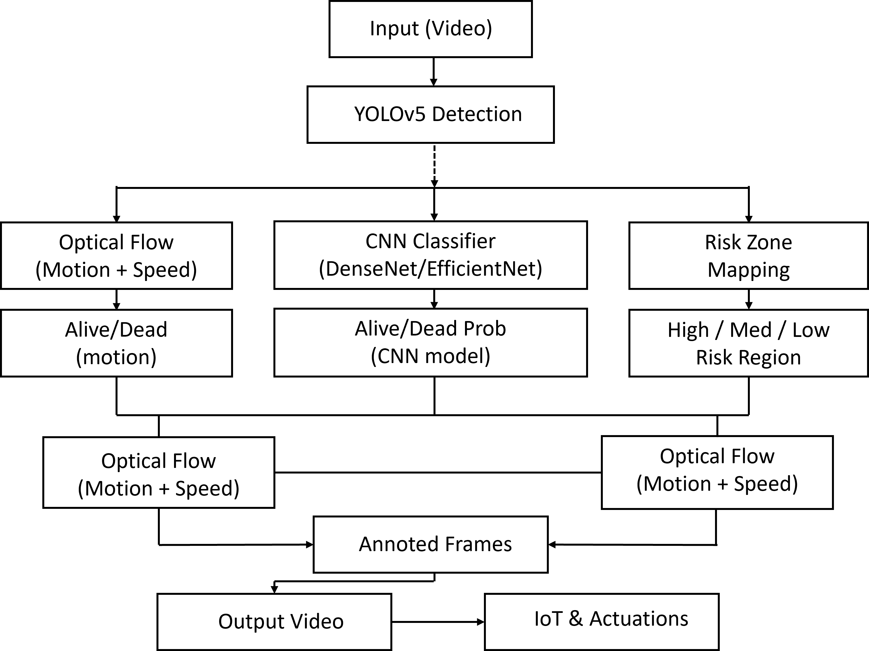
Fig. 1. System Architecture Flowchart of the RHPA Pipeline

- D1: Object Detection (YOLOv5xu)
The first dimension utilizes the YOLOv5xu architecture. This variant is optimized for identifying small-to-medium objects (animals) in complex road backgrounds.
  - Input: Real-time feeds from dashcams or roadside surveillance.
  - Function: Boundary box regression and optical flow- based speed tracking.
The loss function considers the Intersection over Union (IoU) to minimize localization errors:
ρ²(b, b^{gt})
C. D3: IoT and Actuation
The hardware layer is controlled by an ESP32 microcon- troller.
- Sensors: Ultrasonic sensors for proximity verifi- cation; DHT sensors for environmental correlation (temp/humidity).
- Actuators: Smart signage (LED Matrices) and in-car buzzers (through TinyML integration).
1: Initialize Camera, ESP32, Models
2: while System is Active do
3: Frame ← CaptureFrame()
4: Objects ← YOLOv5xu.Detect(Frame)
5: for each Object in Objects do
6: if YOLO detects Animal then
7: Extract bounding box coordinates
8: Crop animal region from Frame
9: State ← CNN_EnsembleModel.Classify(CroppedRegion)

10: Movement ← OpticalFlow.Analyze(Frame, Previ- ousFrame)
11: Speed ← CalculateSpeed(Movement, Bounding- Box)
12: RiskZone ← DetermineRisk(Speed, State)
13: if State == ALIVE AND RiskZone == HIGH then
14: Trigger: High Risk Alert
15: Action: Activate Buzzer (Beep)
16: Action: Auto-decelerate Vehicle (No sudden break)
17: Log: Update Dynamic Danger Map

L_{IoU} = 1 − IoU + c2 + αv (1)
18: else if State == DEAD then
19: Trigger: Low Risk / Obstacle Alert

Where ρ is the Euclidean distance between the center points and αv represents the consistency of the aspect ratio.

- D2: Classification (Ensemble Learning)
Once an animal is detected, the Region of Interest (ROI) is passed to a classification module to determine the state: Alive vs. Dead. We employ an ensemble of two distinct CNN architectures to maximize reliability.
- DenseNet121: Using dense connectivity to mitigate the problem of vanishing projects, ensuring that feature maps are preserved throughout the network. This is crucial for detecting subtle features, such as breathing or posture.
- EfficientNet-B3: The compound scaling balances depth, width, and resolution, providing high accuracy with lower computational cost.
- Ensemble Logic: The final classification probability
P_{final} is derived using a weighted average:
Pfinal = w1 · PDenseNet + w2 · PEfficientNet (2) Where w₁ + w₂ = 1. Based on validation metrics, we assign
w₁ = 0.5 and w₂ = 0.5.
20: Action: Notify Driver (Avoidance)
21: Action: Send GPS to Municipal Corp (Cleanup)

22: Log: Update Roadkill Hotspot Database
23: end if
24: SaveFrame(Frame, OutputVideo)
25: end if
26: end for
27: end while
- Implementation and Results
- Experimental Setup
The models were trained on a custom dataset comprising various vertebrates (cows, dogs, snakes, etc.) under diverse lighting conditions. The system was tested in a pilot in 4 locations over 1.5 months.
- Performance Metrics
The models were evaluated based on Precision, recall, and F1-Score.
The overall system precision (Detection + Classification pipeline) is approximately 95%.

TABLE I
Model Performance Comparison

Model | Task | Accuracy
YOLOv5xu | Object Detection | 93.0%
DenseNet121 | Classification (State) | 93.67%
EfficientNet-B3 | Classification (State) | 93.62%

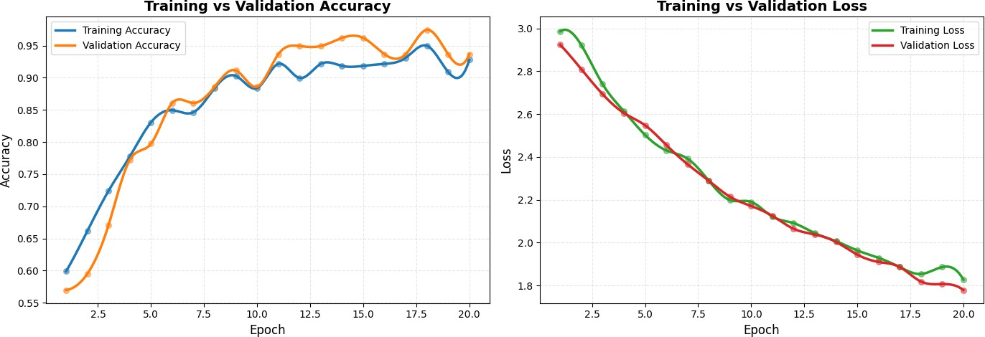

Fig. 2. Training vs Validation Accuracy and Loss curves for DenseNet121 model showing convergence over 21 epochs

Figure 2 illustrates the training dynamics of the DenseNet121 classifier. The model demonstrates stable con- vergence with training and validation accuracies reaching approximately 93% by epoch 18, while both loss curves steadily decrease from 3.0 to below 2.0, indicating effective learning without significant overfitting.
- Impact Analysis
During the pilot phase, the system’s interventions (smart signage warnings and driver alerts) resulted in an estimated 36% reduction in traffic fatalities compared to historical data for the same route.
- Policy Advocacy and Heatmaps
Beyond immediate prevention, this project serves a long- term legislative goal. By logging the GPS coordinates of every "Dead" classification, we generate high-resolution Heatmaps.
Application for Authorities:
  - Hotspot Identification: Pinpointing specific road seg- ments (Blackspots) where animals frequently cross.
  - Infrastructure Planning: Data-backed recommenda- tions for constructing underpasses or overpasses.
  - Resource Allocation: Optimization of routes for mu- nicipal cleanup crews based on real-time notifications.
- Conclusion
The RHPA initiative effectively connects cutting-edge tech- nology with environmental principles. The system provides customized reactions that guarantee passenger safety while actively protecting animals, going beyond basic detection to sophisticated status categorization (Alive vs. Dead). For the long-term wellbeing of our road ecosystems, including this data into municipal policy frameworks guarantees that the answer is both curative and reactive. Future research will concentrate on adding nocturnal species to the data set and including thermal imaging for detection at night.
References
- I. S. Ahn and M. J. Bae, “A Study on the Sound Warning System for Prevention of Roadkill Accident,” International Journal of Engineering Research and Technology, vol. 11, no. 10, pp. 1605-1618, 2018.
- R. van der Ree, D. J. Smith, and C. Grilo, Handbook of Road Ecology. Chichester, UK: Wiley, 2015.
- A. Torres et al., “Assessing large-scale wildlife responses to human infrastructure development,” Proc. Nat. Acad. Sci., vol. 113, no. 30,
pp. 8472–8477, 2016.
- F. van Langevelde and C. F. Jaarsma, “Using traffic flow theory to model traffic mortality in mammals,” Landscape Ecol, vol. 19, no. 8,
pp. 895–907, 2005.
- G. S. Ferrante et al., “Evaluating YOLO architectures for detecting road killed endangered Brazilian animals,” Scientific Reports, 2023.
- C. Grilo et al., “Global Roadkill Data: a dataset on terrestrial vertebrate mortality caused by collision with vehicles,” Scientific Data, 2024.
- L. Balcˇiauskas et al., “A Review of Wildlife-Vehicle Collisions: A Multi- disciplinary Path to Sustainable Transportation and Wildlife Protection,” Sustainability, 2025.
- J. Arca-Rubio et al., “The distribution of vertebrate roadkill varies by season, surrounding environment, and animal class,” European Journal of Wildlife Research, 2023.
- I. M. F. Cassimiro et al., “How did the animal come to cross the road? Drawing insights on animal movement from existing roadkill data and expert knowledge,” Landscape Ecology, 2023.
- R. T. Forman and L. E. Alexander, “Roads and their major ecological effects,” Annual Review of Ecology and Systematics, 1998.

